**AICT PROJECT**

NAME:

SYED GHAYUR HUSSAIN (231570)

HUZAIFA BIN ASAAD (231654)

GitHub:

<https://github.com/ghayurcodes/ict-project>

https://github.com/huzaifaasad/Samurai-Website

BSCS-1B

Date: 24/12/2023

Homepage:

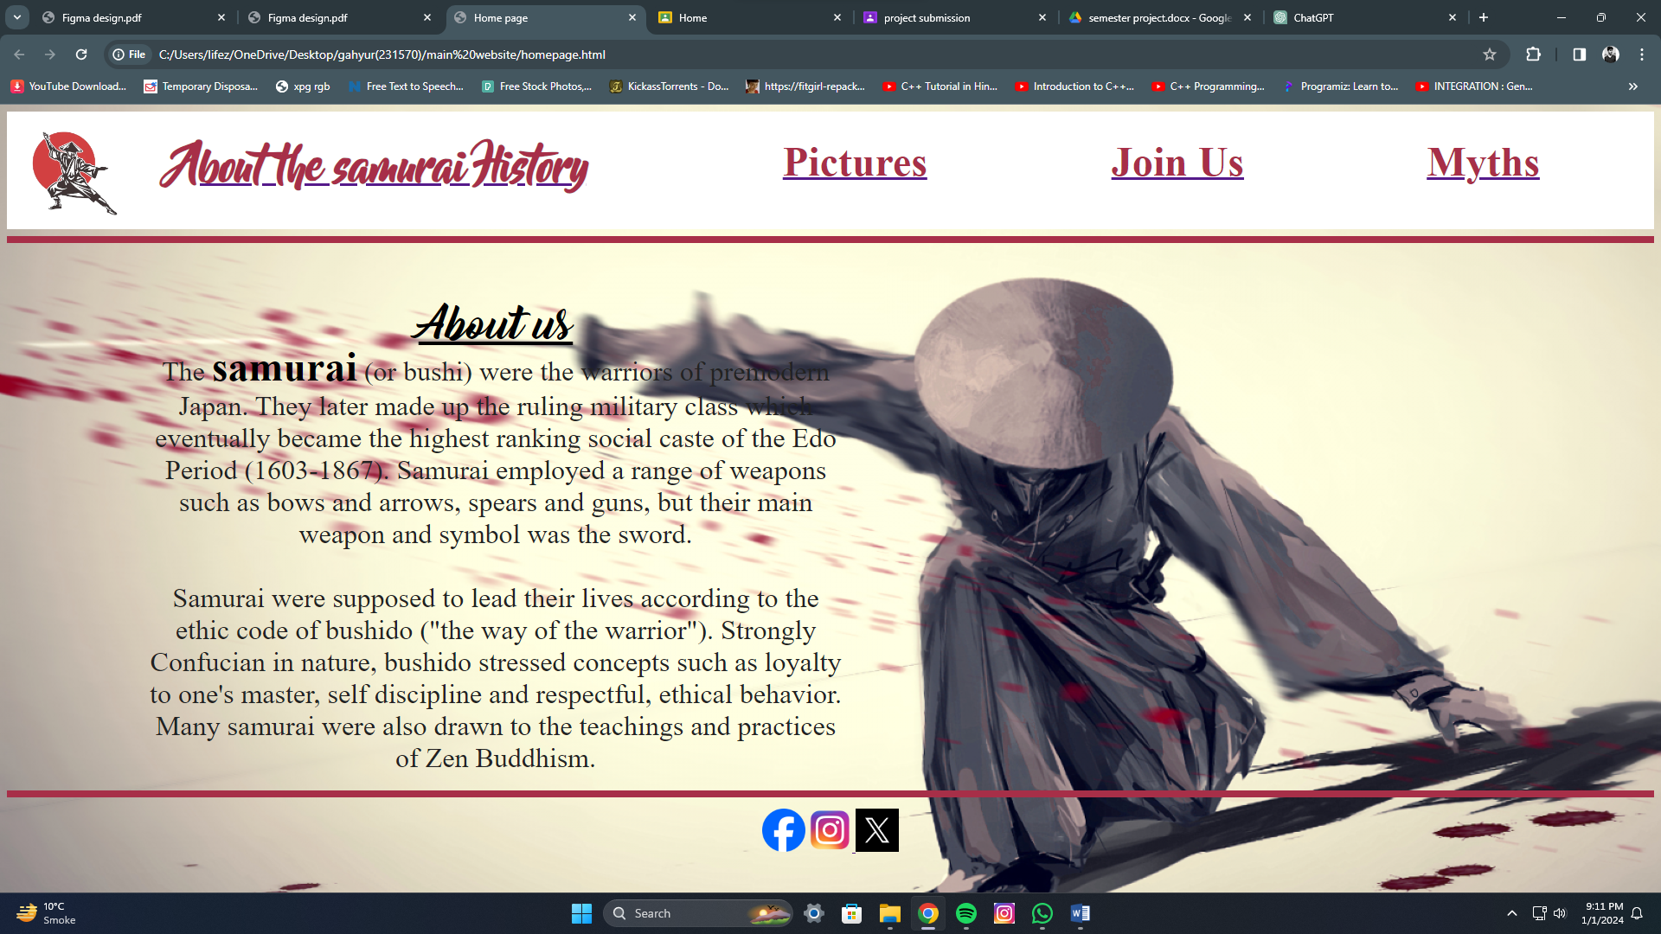Top of Form

Welcome to our immersive samurai experience! The homepage of our website is a captivating introduction to the rich and legendary world of samurai culture. A harmonious blend of historical charm and modern aesthetics, the page greets visitors with a visually stunning layout, adorned in colors that echo the spirit of the samurai.

Navigate seamlessly through our user-friendly design, where the essence of the samurai is celebrated. Engage with interactive elements that beckon you to explore further, setting the stage for an enlightening journey into the realms of honor, discipline, and timeless tales. Join us on this adventure as we unravel the mystique of the samurai way!

Pictures page:

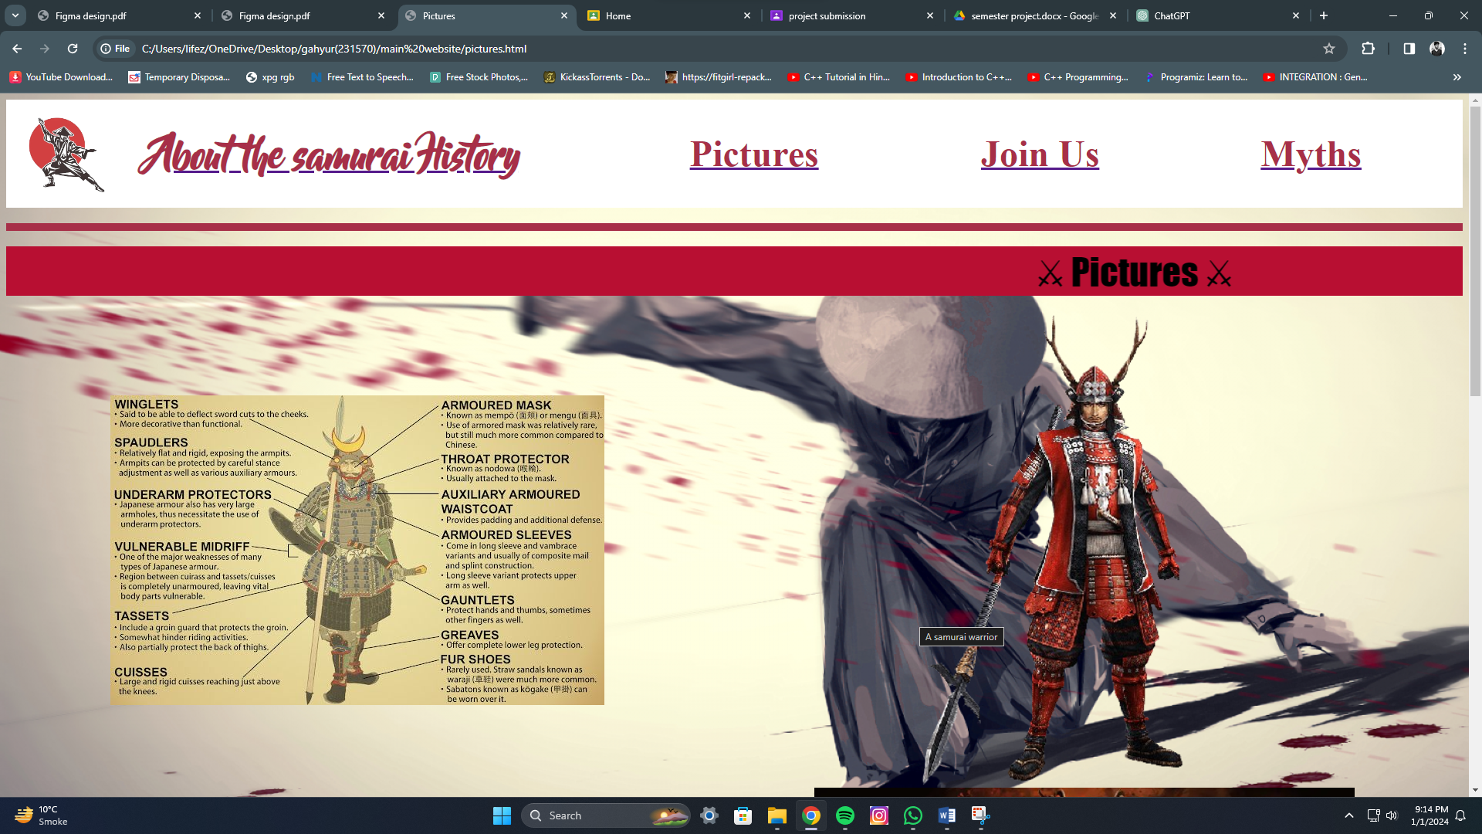

Dive into our Pictures page to discover the stunning world of samurai visuals. From cool armor to powerful poses, it's a quick journey through awesome samurai pictures. Click around easily to enjoy the coolness of samurai style. Get ready e the best snapshots of the samurai life!

Myth page:

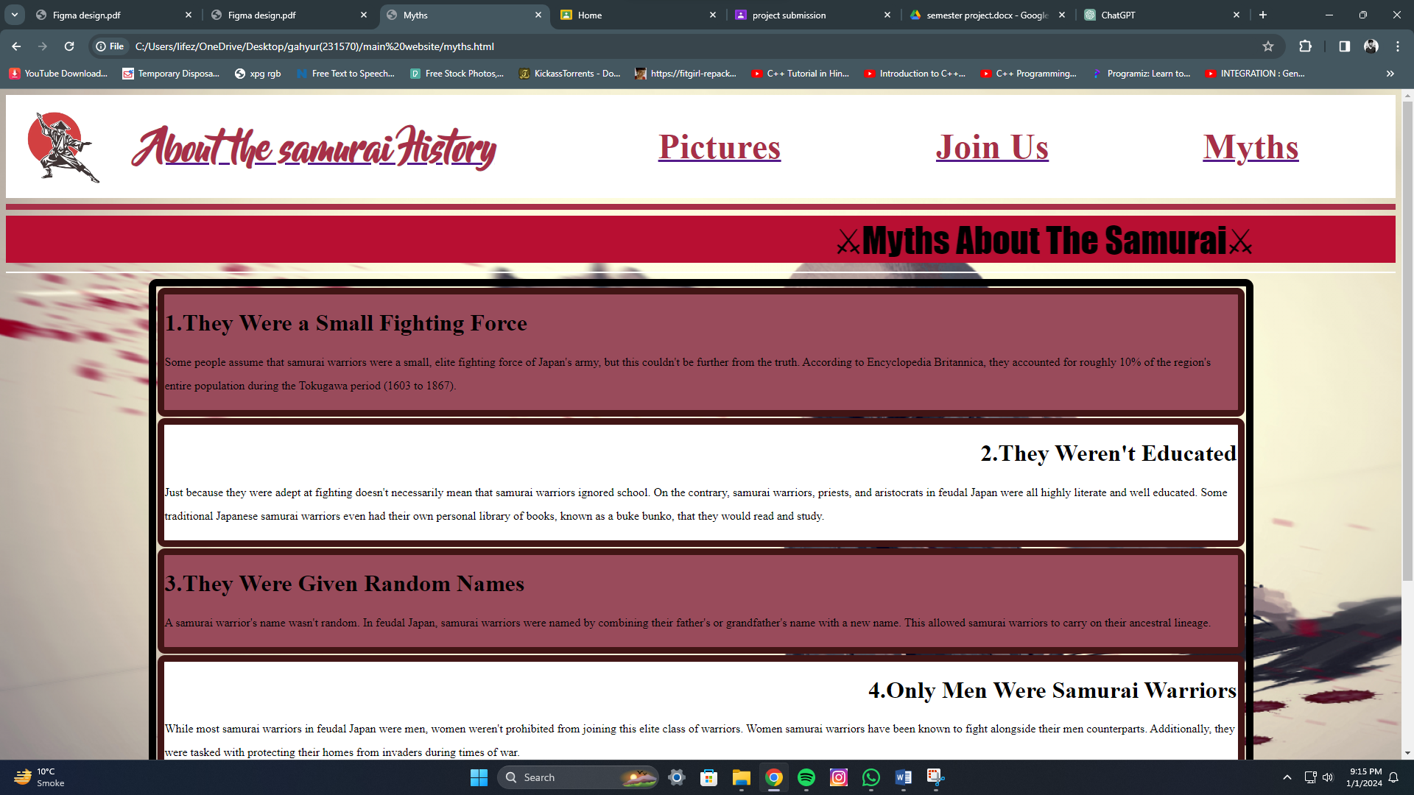

Uncover the enchanting world of samurai myths on our Myths page. Discover captivating stories of honor, bravery, and adventure that define the samurai spirit. It's a quick trip into the legendary tales that make samurais truly epic. Click to explore the mythical side of the samurai journey!

Join us page:

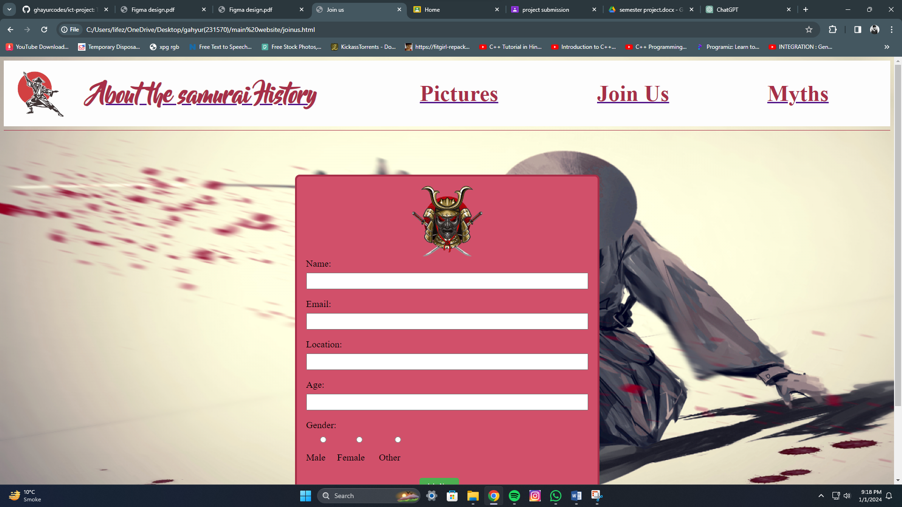

Ready to join the samurai community? Our Join Us page is your gateway. Learn about the perks, fill out a simple form, and become a part of our samurai squad. Click to start your journey with us and unlock exclusive benefits. Don't miss out – join the samurai family today!

⭐⭐⭐⭐⭐⭐⭐⭐⭐